TASK 10 — SQL Query Generation using Structured Prompting
AIM
To design a structured prompt containing database schema, table details, relationships, and requirements so that an LLM can generate an appropriate SQL query.
PROCEDURE
1. Define the database and SQL dialect.
2. Provide the table names, columns, data types, and primary/foreign-key relationships.
3. State the exact query requirement.
4. Specify filtering, joining, sorting, and output requirements.
5. Construct a structured prompt using the database information.
6. Submit the prompt to the LLM and obtain the SQL query.
7. Validate the generated query against the given schema and sample data.
PROMPT
ROLE:
You are an expert SQL developer.
DATABASE:
MySQL
TABLES:
Students(student_id INT PRIMARY KEY, student_name VARCHAR(100), department VARCHAR(50))
Subjects(subject_id INT PRIMARY KEY, subject_name VARCHAR(100))
Marks(student_id INT, subject_id INT, marks INT)
RELATIONSHIPS:
Students.student_id = Marks.student_id
Subjects.subject_id = Marks.subject_id
TASK:
Generate an SQL query to display student name, subject name, and marks
for students who scored more than 80 marks.
REQUIREMENTS:
- Use appropriate JOIN operations.
- Filter marks greater than 80.
- Sort results by marks in descending order.
OUTPUT FORMAT:
Return the SQL query followed by a short explanation.

INPUT
Database: Student Management Database
SQL dialect: MySQL
Required result:
Display student_name, subject_name, and marks where marks > 80,
using the supplied table relationships and sorting by marks descending.

OUTPUT
OUTPUT — PLACE GENERATED OUTPUT IMAGE HERE
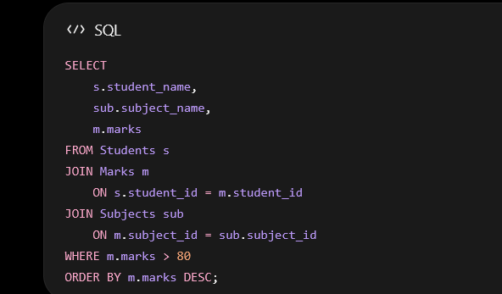

RESULT
The structured prompt successfully provides the LLM with the database schema and query requirements needed to generate and validate an appropriate SQL query.

